1)
Step 1: Open PowerShell as Administrator
- Press Windows.
- Search for PowerShell.
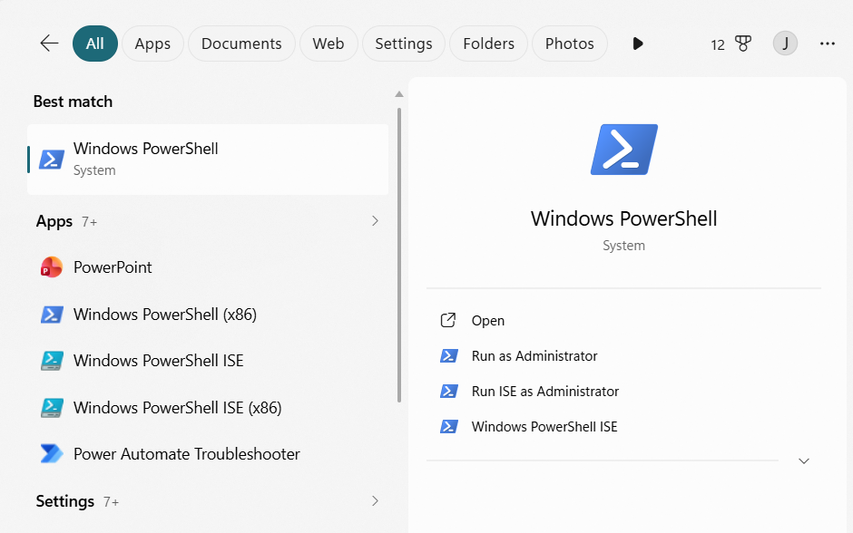
- Right-click Windows PowerShell.
- Click on “Run As Administrator”.
Step 2:
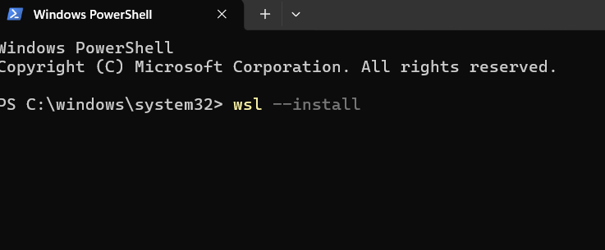
Step 3: Restart Your Computer
After installation, restart your PC when prompted.
Step 4: Complete Ubuntu Setup
After restarting:
- Ubuntu opens automatically (or search for Ubuntu in the Start menu).
- Wait for the installation to finish.
- Create a Linux username.
Example:
Enter new UNIX username: jahnavi

Step 5: Create a Password
You'll then be prompted to create a password.
New password: ****
Retype new password:****
Step 6: Update Ubuntu
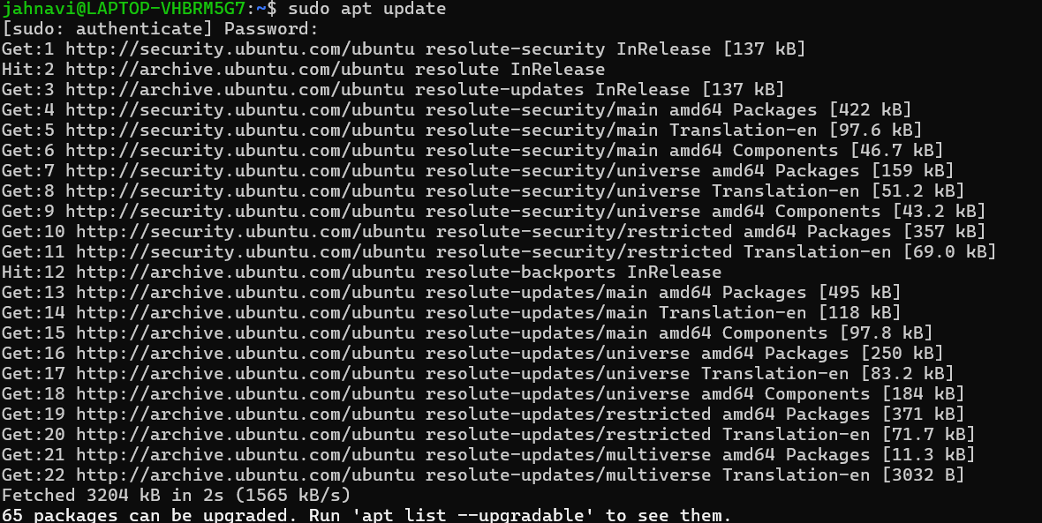
Step 7: Install GCC (C Compiler)
Install the GCC compiler and required development tools using:
“sudo apt install build-essential”.
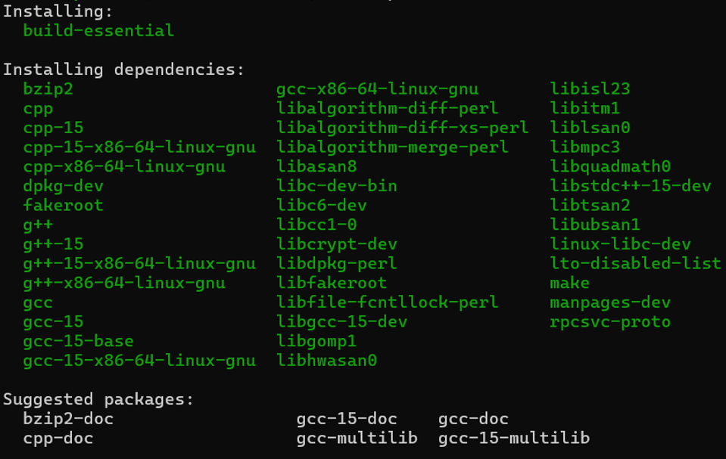
Step 8: Verify the Installation
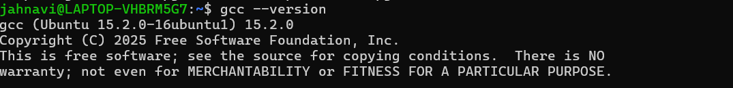

GITHUB REPOSITORY:
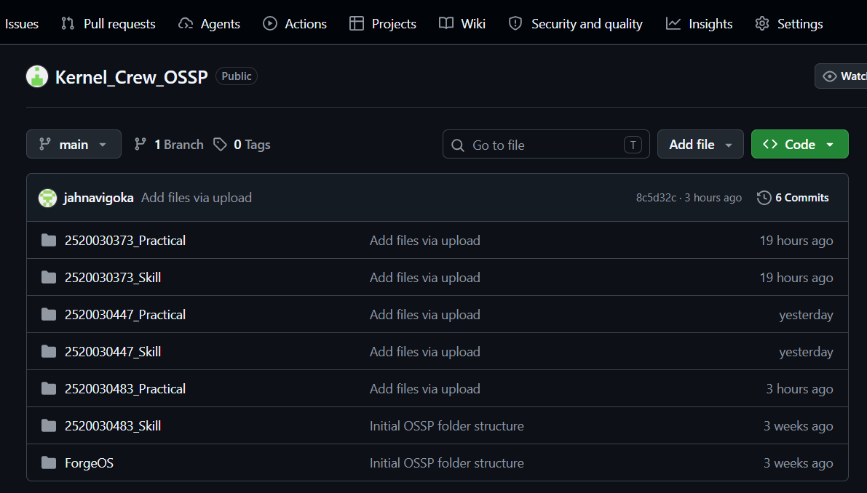
Fork Process:
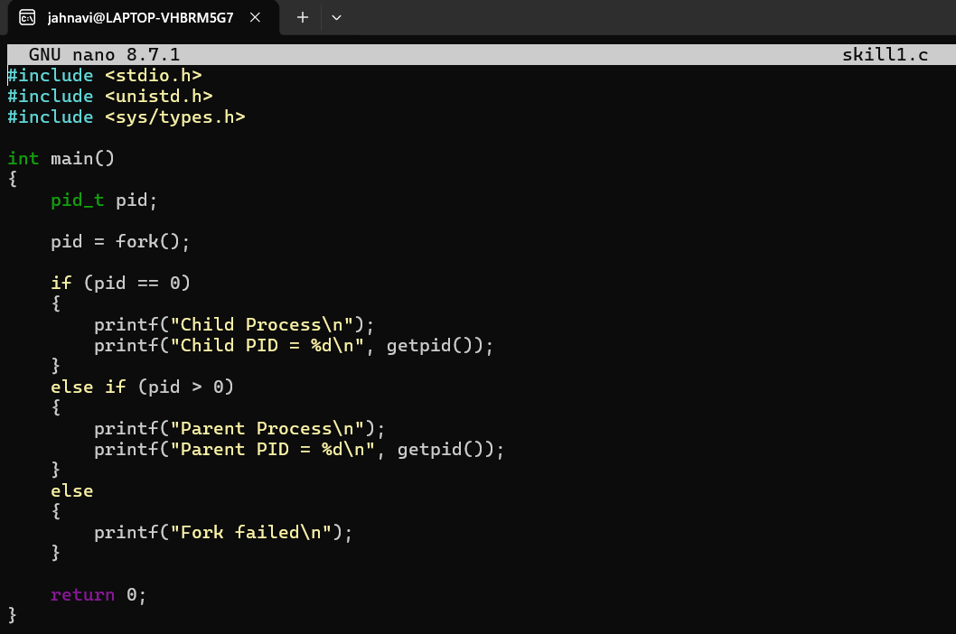
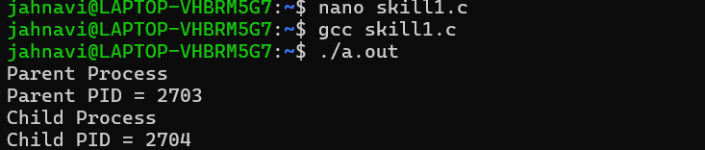

exec() process:
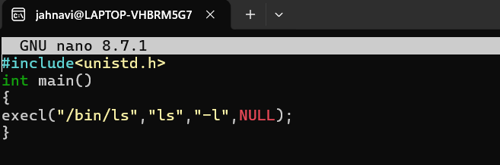
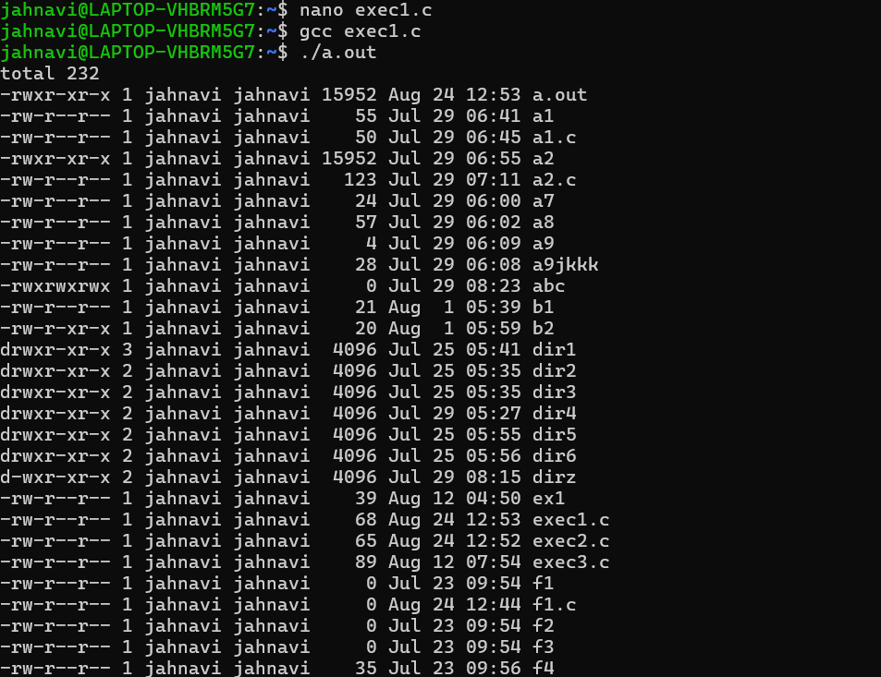
Parent–Child Relationships:
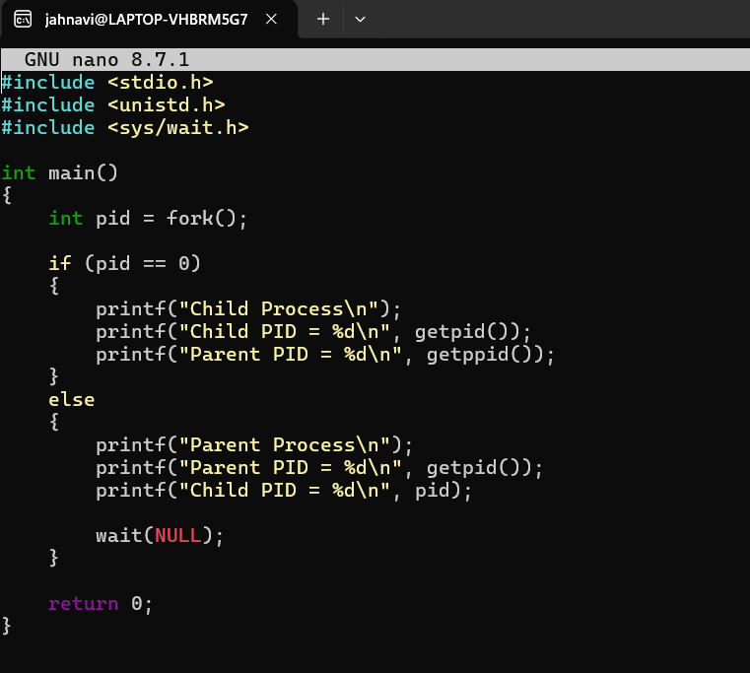
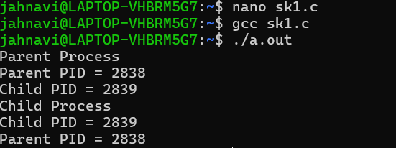

Observation Table:
Topic: | Command/Function: | Observation:
Parent-child relationship | fork() | Creates a child process
Parent PID | getpid() | Displays parent's PID
Child PID | getpid() | Displays child's PID
Child's parent | getppid() | Shows parent's PID
Process tree | pstree -p | Shows parent-child hierarchy
System call tracing | strace ./parent | Shows kernel system calls
Parent waiting | wait(NULL) | Parent waits for child

2)
